Call for Special Sessions and/or Side Events
Introduction
The IAHR World Congress is the main biennial dissemination forum in this field. For this reason, the different Committees involved in the organization of the next congress to be held in 2025 have proposed to open a call for proposals for Special Sessions that fit within the general topic of the Congress and its different themes.
A special session is a special type of parallel session with a particular title and content, under the responsibility of a particular institution, consortium of institutions or convener(s). A Special Session is fully integrated into the Congress programme and is open to every registered Congress participant. It does not require special funding from the Congress. Participants in the session, including convener(s) and speakers, must be fully registered for the Congress. The convener(s) has the right to invite participants to the session at his/her own expense, possibly with a specific sponsor. Special sessions will take place within the normal time schedule of the congress, whilst trying to avoid an overlap with similarly themed sessions.
Evaluation process
A Special Session needs to be validated by the International Scientific Committee (ISC) and the National Organising Group (NOC) of the Congress in order to verify that the scientific level of the session’s content is consistent with the level of the other sessions. The validation process is the following:
- Proposals are sent through the congress website according to the established form and deadline.
- Proposals must include a title, brief description and a list of potential speakers.
- Final decision on the selected sessions is taken by ISC and NOC and communicated on time to the convener(s).
Convener(s) responsibilities
Convener(s) will be responsible for the design and organization of the special session, which will have an estimated duration of 1 hour and 30 minutes. They are fully responsible for mobilising everything necessary for the session. The speakers in the session must be fully registered at the Congress.
More information
To propose a special session, or to make changes to one already submitted, please contact the NOC at abstracts@iahr2025-singapore.com.sg before 30 September 2024.

Key dates
- Special Sessions Submission Opens: 1 July 2024
- Special Sessions Submission Closes: 30 September 2024
- Notification of Acceptance (Special Sessions): 1 December 2024

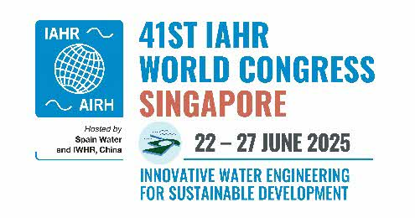
Special Session or Side Event proposal
Session Title
Session description
Organised by (Session Chair)
Alignment with congress theme (please select)
Duration (max 90 min)
Speakers (max 5-6, include names, organisation, country)
Contact person (include name and email)

